


Movie Recommendation – CPIT 440

With Deep Respect, Submitted to Dr. Mahmoud
Department of Information Technology
At King Abdulaziz University (KAU)

Phase 2 - Comprehensive Report
Muath Abbas Eissa [2338818]
Meshal Ahmad AlAjlani [2335521]
Hashim Yaser Bajaber [2336321]
Mohammed Khalid Alahmadi [2340345]

Date of Submission
6th December 2025

Table of Contents
Introduction 2
Problem Goal 3
Data Mining Formalization 3
Data 3
Type of Data 3
Splits (Train-Test) 4
Source of Data 4
Dataset Description 4
Representation of Missing Values 4
Visualization 5
Histogram - Rating Distribution 5
Boxplot: Release Year 5
Scatter Plot: Runtime vs Rating 6
Correlation Study 6
Related Paper 6
Paper Title and Authors 6
Used Models 6
Which Model Was Better? 7
Summary 7
Data Preprocessing 7
Data Preparation Details 7
Train / Test Split 8
Feature Selection 8
Models Training 8
Algorithms Used 8
Cross Validation 8
Models Evaluation 9
Performance Metrics 9
Model Performance Comparison 9
Model Selection and Justification 9
Tools and Libraries 9
Difficulties / Challenges 10
Future Work 10
Work Division Table 10
References 11

Introduction
This project focuses on developing a movie recommendation system that identifies meaningful patterns in movie data and groups similar movies together using clustering techniques. The system applies the K-Means clustering algorithm to analyze key movie attributes, particularly genre information along with numerical factors such as rating and runtime.
By grouping movies based on shared characteristics, the system can better understand similarity patterns and provide relevant recommendations to users based on the cluster each movie belongs to.

Problem Goal
The goal of this project is to build a recommendation system that predicts what movies a user may enjoy by examining similarities between movies. The model identifies movies that share similar genres and numerical characteristics and uses this information to generate suggestions.
The expected outcome is a model that uses K-Means clustering to form meaningful groups of similar movies. Recommendations are then generated by selecting movies from the same cluster as the user’s chosen film.

Data Mining Formalization
This project is formalized as a clustering task.
K-Means clustering is used to group movies based on a combination of content-based attributes and numerical features. Since machine learning algorithms cannot directly interpret text, the genre information (main genre and side genre) is converted into numerical vectors using CountVectorizer. This allows the algorithm to measure similarities between movies based on their genre descriptions.
In addition to genre vectors, numerical attributes such as rating and runtime are included directly in the feature set. Together, these features allow the model to cluster movies based on both content similarities and quantitative differences.

Data

Type of Data
The dataset contains movie metadata, including:
- Movie title
- Year
- Director
- Actors
- Rating
- Runtime (in minutes)
- Censorship classification
- Total gross
- Main genre
- Side genre

For this project, the clustering model specifically uses:
- Main Genre
- Side Genre
- Rating
- Runtime(Mins)
These attributes were selected because they play the biggest role in defining similarity between movies.
The dataset includes both numerical attributes (such as rating and runtime) and categorical/textual attributes (such as genres).

Splits (Train-Test)
The clustering model (K-Means) does not require a train-test split. EDA visuals and preprocessing are applied to the full dataset before fitting the clustering model.

Source of Data
The dataset is:
IMDB_All_Genres_etf_clean1.csv, an IMDb-based movie dataset containing 5562 rows and 10 attributes.

Dataset Description
The dataset was successfully loaded and inspected:
- First 5 rows and last 5 rows were printed to confirm structure.
- Total columns: 10
- Total rows: 5562

Representation of Missing Values
The dataset does not use numpy.nan, "unknown", or "?" as missing values — all entries are complete.
- Numerical: Year, Rating, Runtime
- Categorical: Movie_Title, Director, Actors, Censor, Total_Gross, main_genre, side_genre

Visualization

Histogram - Rating Distribution
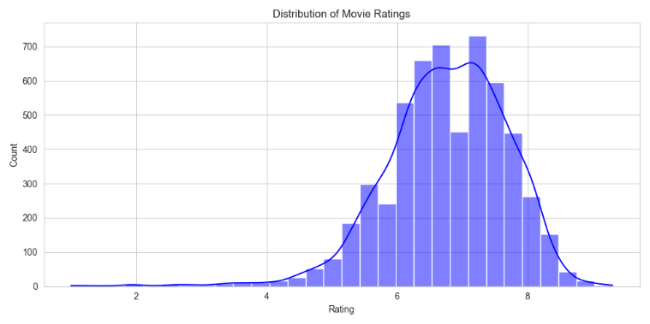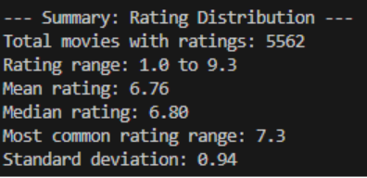

Boxplot: Release Year
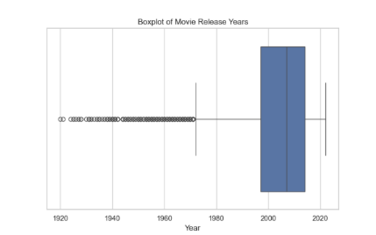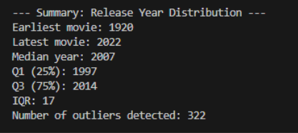

Scatter Plot: Runtime vs Rating
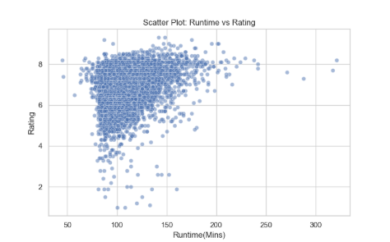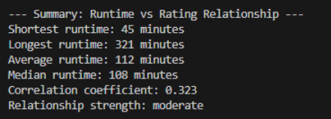

Correlation Study
A correlation matrix was generated using numerical attributes.
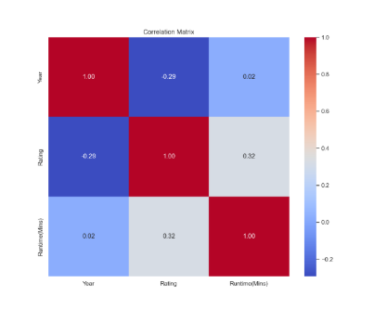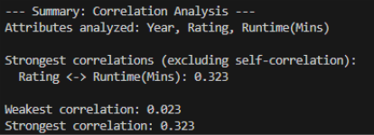

Related Paper
Paper Title and Authors
Paper Title: Movie Recommendation with K-Means Clustering and Self-Organizing Map Methods
Authors: Eugene Seo and Ho-Jin Choi

Used Models
The paper presents a movie recommendation approach based on clustering. It examines two unsupervised machine learning models: K-Means Clustering and Self-Organizing Maps (SOM). Both models are used to group similar items so that the system can generate more meaningful recommendations. K-Means focuses on providing fast and efficient grouping, while SOM forms more detailed clusters but requires higher computational cost.

Which Model Was Better?
The study found that SOM produced slightly more accurate clusters due to its ability to capture complex patterns. However, K-Means was significantly faster and more practical for large datasets. The authors concluded that K-Means offers the best balance between accuracy and efficiency, making it a suitable choice for real-world recommendation systems.

Summary
In our project, we explored the movie dataset, analyzed key attributes, and applied K-Means clustering to group similar films based on their main and side genres, along with important numerical features such as rating and runtime. By converting genre information into numerical form and combining it with scaled numeric attributes, the model is able to identify meaningful similarity patterns between films.
This clustering step provides a strong foundation for developing a content-based movie recommendation system, where similar films can be suggested to users based on the cluster in which each movie is placed.

Data Preprocessing

Data Preparation Details
Data preprocessing was performed to prepare the dataset for clustering and recommendation. An initial examination of the dataset confirmed that the required attributes were complete, with no missing values in the numerical fields (Rating, Runtime(Mins), Year) and no placeholders such as "?", "Unknown", or NaN. This allowed the project to proceed without the need for imputation or removal of incomplete records.

To support clustering based on movie content, several feature engineering steps were applied. First, the descriptive attributes of each movie—such as the Movie Title, Main Genre, and Side Genre—were combined into a single text-based feature. This ensures that the model captures important contextual information about each movie in a unified form.
Next, the combined text field was converted into numerical form so that it could be used by the K-Means algorithm. This step allows the model to compare movies based on their text descriptions, such as similarities in titles and genres. Movies with more similar words or categories naturally become closer to each other in the data, helping the clustering algorithm group them more effectively.
Additionally, numerical attributes such as Rating, Runtime, and Year were included directly in the input data to preserve important quantitative differences between movies. These numeric values help distinguish films with similar text descriptions but different levels of quality, pacing, or release periods.
The final feature matrix X was constructed by combining the numerical representations of text data with the additional numeric attributes. This matrix serves as the input to the K-Means algorithm, allowing it to group movies based on both content similarity and measurable characteristics.

Train / Test Split
Since this project applies unsupervised clustering, a train–test split was not required. All movies were used in the clustering process because K-Means does not rely on labeled output data.

Feature Selection
Feature selection was carried out by choosing attributes that meaningfully describe a movie’s content and measurable characteristics. The features used for clustering were:
- Main Genre
- Side Genre
- Rating
- Runtime
The genre attributes were combined into a single text feature and transformed into numerical form using CountVectorizer, while the numerical attributes were scaled using MinMaxScaler. These numeric attributes allow the model to recognize differences between movies that share similar genre descriptions but vary in their rating level and overall duration.

Models Training

Algorithms Used
The clustering model used in this project is the K-Means algorithm. It was trained using the prepared feature matrix with the settings n_clusters = 180, random_state = 42, and n_init = 10.
To decide on the number of clusters, the Elbow Method was applied by testing several values of K and observing how the Within-Cluster Sum of Squares (WCSS) changed. Although there was no clear or strong elbow point, increasing the number of clusters helped form more meaningful groups, especially because the dataset contains many different genres and sub-genres. For this reason, K = 180 was selected, as it produced movie clusters that were more consistent and better aligned with genre-based similarities.

Cross Validation
Traditional cross-validation was not applied because K-Means is an unsupervised learning algorithm that does not depend on labeled target values. Instead, internal validation metrics were used to evaluate clustering quality.

Models Evaluation

Performance Metrics
The clustering model was evaluated using two measures: the Within-Cluster Sum of Squares (WCSS) and the Silhouette Score. WCSS was calculated for different values of K to observe how the compactness of the clusters changed as more groups were added. Although the Elbow Method did not show a very clear turning point, testing several values helped understand how the dataset behaved.
After selecting the final model, the Silhouette Score was computed. The score for K = 180 was 0.7947, which is fairly high. This does not mean the model is unusually powerful; rather, it reflects the natural structure of the data. Movies from different genres tend to be very different from each other, so they form clear and separate groups. The score simply confirms that movies within the same cluster are similar, while movies in different clusters are well separated.

Model Performance Comparison
Only one clustering algorithm, K-Means, was used in this project. Because of this, the evaluation focused on comparing different values of K instead of comparing multiple models. WCSS was used to check how compact the clusters became, and the Silhouette Score helped verify that the final grouping made sense.

Model Selection and Justification
The final model used 180 clusters. This number was chosen after experimenting with several values and reviewing how the clusters changed. The high Silhouette Score showed that the groups were clearly separated, mainly because genre information naturally divides movies into distinct categories.
A manual check of different clusters supported this result. Movies inside the same cluster often shared similar genres and themes, confirming that the chosen clustering setup produced meaningful groups that can be used for generating recommendations.

Tools and Libraries
We used Python 3 with the following libraries:
- pandas and numpy for data loading and manipulation
- scikit-learn for K-Means clustering, CountVectorizer, MinMaxScaler, and Silhouette Score evaluation
- matplotlib and seaborn for exploratory visualization

Difficulties / Challenges
Several challenges were encountered during this phase of the project. Preparing the data required careful handling of inconsistent genre information, since movies often included multiple genre labels that needed to be merged into a usable form. Another difficulty was determining how to balance the influence of different features, particularly numerical values such as movie ratings and runtime, which required multiple adjustments and trials to achieve a reasonable effect on clustering.
Choosing the appropriate number of clusters also presented challenges. The WCSS values did not form a clear “elbow,” which made it necessary to test several values of K and rely on Silhouette analysis to judge cluster quality. Additionally, evaluating whether the resulting clusters were meaningful required manual inspection of movie groups.
Overall, the process of building and tuning the clustering model involved iterative experimentation to ensure that the final groupings aligned well with the thematic and structural similarities between movies.

Future Work
Future improvements to this system could include adding user-based recommendation methods so that suggestions become more personalized. Different clustering techniques, such as hierarchical clustering or DBSCAN, may also be tested to see whether they form better movie groups than K-Means. Another improvement could involve automatically learning which movie features are most important, instead of choosing them manually. Finally, the system could be evaluated using real user feedback or viewing history to better measure how effective the recommendations are and to guide further enhancements.

Work Division Table
Group Member | Task
Member 1 | Data preprocessing, feature engineering, cleaning
Member 2 | Model training, K-Means clustering, evaluation
Member 3 | Recommendation logic, scoring system, testing
Member 4 | Data visualization, report writing, presentation slides

References
[1] E. Seo and H.-J. Choi, “Movie Recommendation with K-Means Clustering and Self-Organizing Map Methods,” International Journal of Computer and Information Engineering, 2014. [Online]. Available: https://www.scitepress.org/papers/2010/27376/27376.pdf
[2] F. Pedregosa et al., “Scikit-learn: Machine Learning in Python,” Journal of Machine Learning Research, vol. 12, pp. 2825–2830, 2011. [Online]. Available: https://scikit-learn.org/stable/
[3] W. McKinney, “pandas: A Foundational Python Library for Data Analysis and Statistics,” Python for Data Analysis, O’Reilly Media, 2012. [Online]. Available: https://pandas.pydata.org/
[4] IMDb Dataset, “IMDB All Genres ETF Clean Dataset,” Kaggle/IMDb, 2023. [Online]. Available: https://www.imdb.com/

